

Practices for Secure Software Report

Table of Contents
Document Revision History 3
Client 3
Instructions 3
Developer 4
1. Algorithm Cipher 4
2. Certificate Generation 4
3. Deploy Cipher 4
4. Secure Communications 4
5. Secondary Testing 4
6. Functional Testing 4
7. Summary 4
8. Industry Standard Best Practices 4

Document Revision History

Version | Date | Author | Comments
1.0 | April 12, 2026 | Ashlynn Borro

Client



Instructions

Submit this completed practices for secure software report. Replace the bracketed text with the relevant information. You must document your process for writing secure communications and refactoring code that complies with software security testing protocols.

- Respond to the steps outlined below and include your findings.
- Respond using your own words. You may also choose to include images or supporting materials. If you include them, make certain to insert them in all the relevant locations in the document.
- Refer to the Project Two Guidelines and Rubric for more detailed instructions about each section of the template.

Developer
Ashlynn Borro

Algorithm Cipher

For this project, I chose to use AES (Advanced Encryption Standard) as the main encryption method. AES is one of the most commonly used encryption algorithms today and is considered very secure, especially when using a 256-bit key. It is also fast, which makes it a good option for web applications like the one Artemis Financial is using.
AES is a symmetric algorithm, meaning it uses the same key to both encrypt and decrypt data. This makes it more efficient compared to asymmetric encryption, which uses two keys. Even though symmetric encryption is faster, it still requires secure handling of the key so it does not get exposed.
Along with encryption, I also used SHA-256 as a hashing function. This is important because it helps verify that data has not been changed during transmission. The checksum created from SHA-256 acts like a fingerprint for the data, so if anything changes, it will be obvious.
In terms of bit levels, AES can use 128, 192, or 256 bits, with 256 being the strongest. SHA-256 produces a 256-bit hash, which makes it very difficult to break or duplicate.
Overall, encryption has improved a lot over time, going from older methods like DES to stronger and more secure ones like AES. Today, AES is basically the standard, especially for systems that deal with sensitive information like financial data, which is why it makes the most sense to use here.

Certificate Generation
Insert a screenshot below of the CER file.
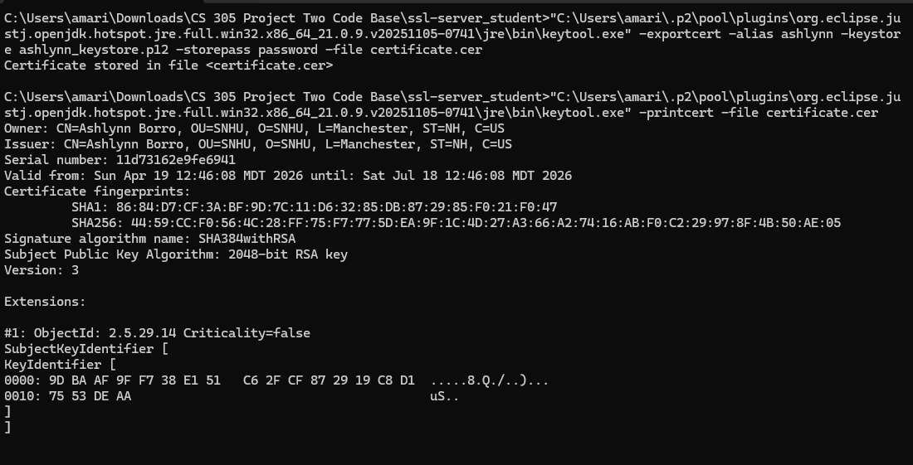

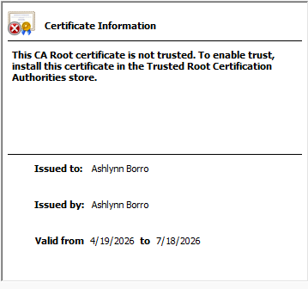

Deploy Cipher
Insert a screenshot below of the checksum verification.
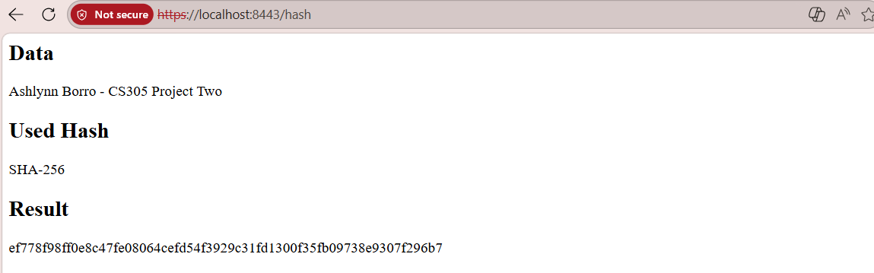
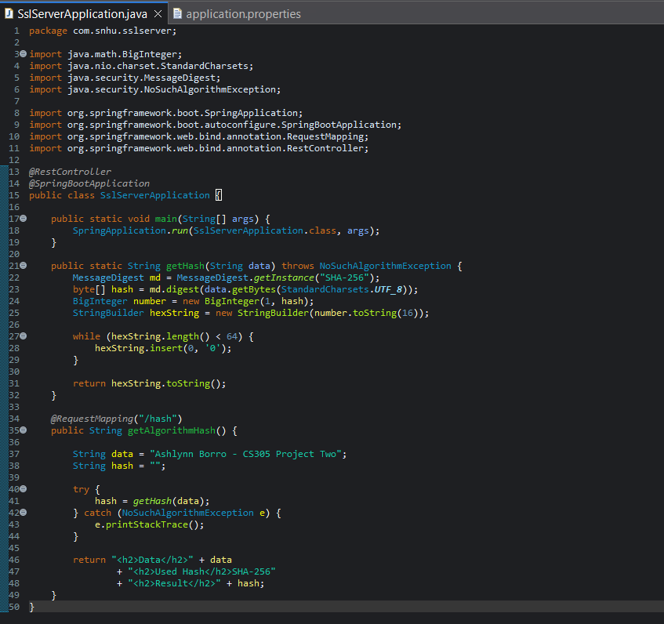
For this step, I refactored the application to implement the SHA-256 hashing algorithm. After updating the code, I ran the application and verified that the checksum was generated successfully using a unique data string containing my name.

Secure Communications

Insert a screenshot below of the web browser that shows a secure webpage.
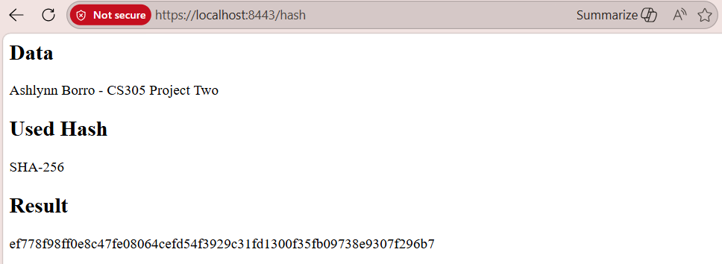
I configured the application to use HTTPS on port 8443 with a self-signed certificate in the keystore. The application loads successfully over HTTPS. I also completed certificate setup and troubleshooting steps, but the browser continued to display a warning because self-signed certificates are not automatically trusted like certificates issued by a public Certificate Authority. Even with the warning, the connection remains encrypted and secure for local testing.

Secondary Testing
Insert screenshots below of the refactored code executed without errors and the dependency-check report.

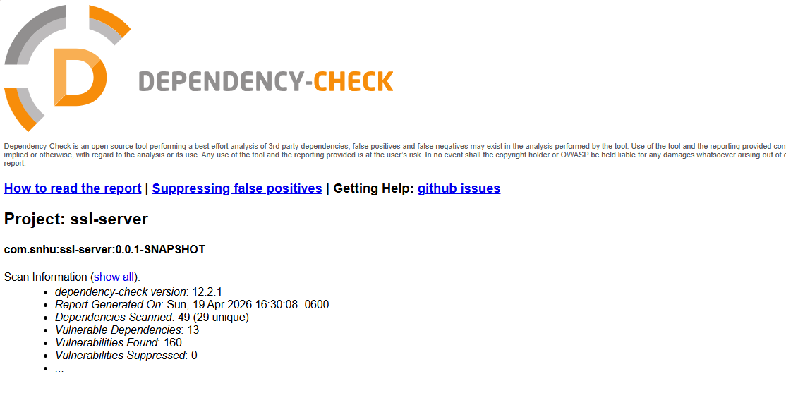
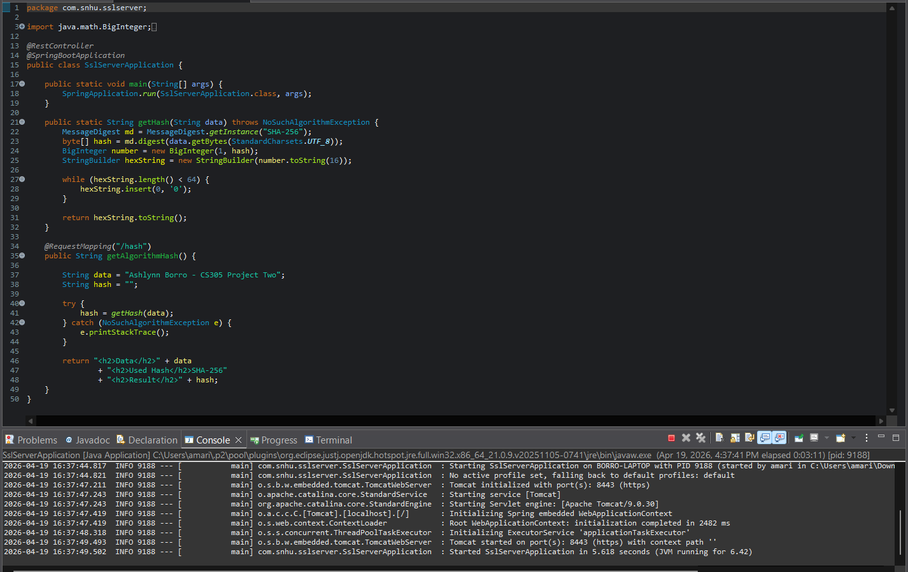
The dependency-check scan was reviewed to verify that no new vulnerabilities were introduced by the refactored code.

Functional Testing

Insert a screenshot below of the refactored code executed without errors.
Functional testing confirmed the code executed without syntax errors. Logic flow was reviewed to ensure correct hashing behavior. Security review confirmed SHA-256 replaced weaker hashing methods and HTTPS was enabled.

Summary
The code was refactored to improve security and better align with secure software testing protocols. Based on the vulnerability assessment process, the main areas addressed included insecure communication, weak hashing practices, and dependency vulnerabilities. To improve security, HTTPS was implemented using a self-signed certificate to encrypt transmitted data, and the hashing method was updated to SHA-256. OWASP Dependency-Check was also used to review project dependencies for known vulnerabilities. Additional layers of security were added through encrypted communication, stronger hashing, and continued testing to verify the application executed successfully after changes were made.

Industry Standard Best Practices

Industry standard best practices were applied throughout the refactoring process to reduce known security vulnerabilities. Secure coding practices included replacing weaker hashing methods with SHA-256, using HTTPS to protect data in transit, and performing static testing with OWASP Dependency-Check. These practices helped maintain the application’s existing security while improving areas of weakness. Applying secure coding best practices is valuable to a company because it helps protect sensitive data, reduces the risk of cyberattacks, improves customer trust, and lowers the cost of fixing security issues later in development.

